Test case 1:

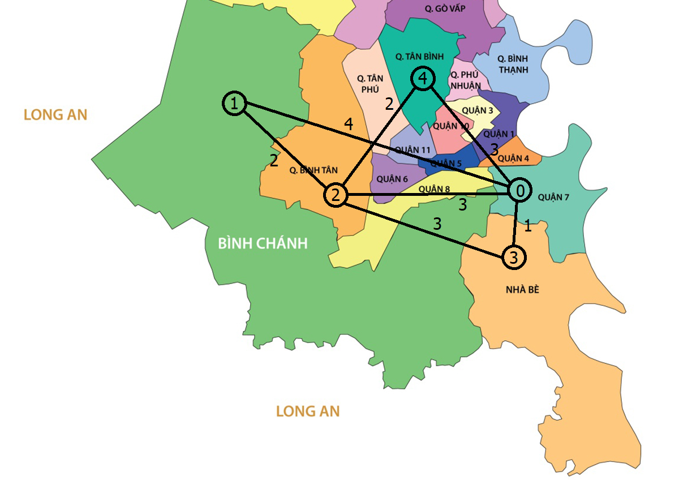

5

0 4 3 1 3

4 0 2 0 0

3 2 0 3 2

1 0 3 0 0

3 0 2 0 0

Quan 7

Binh Chanh

Quan Binh Tan

Nha Be

Quan Tan Binh

Test case 2:

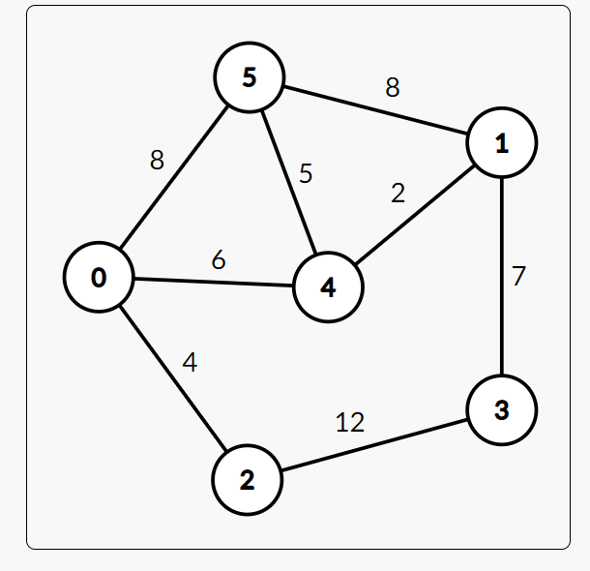

6

0 0 4 0 0 8

0 0 0 7 2 8

4 0 0 12 0 0

0 7 12 0 0 0

6 2 0 0 0 5

8 8 0 0 5 0

Quan 3

Quan 5

Quan 10

Quan 11

Tan Binh

Quan Binh Tan

Test Case 3:

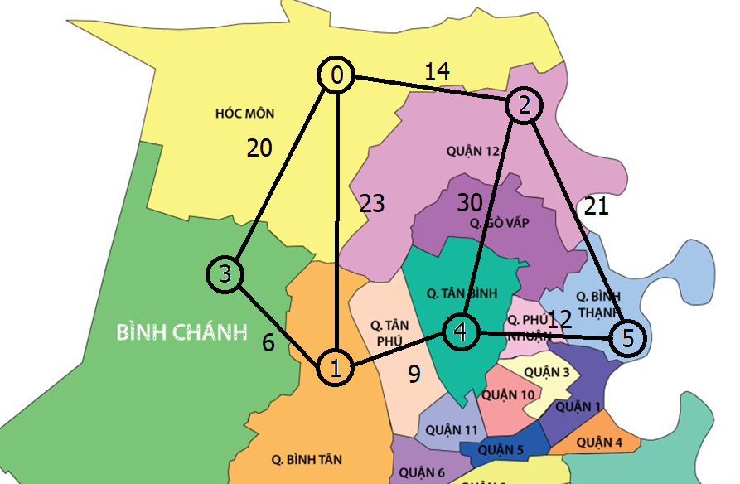

6

0 23 14 20 0 0

23 0 0 6 9 0

14 0 0 0 30 21

20 6 0 0 0 0

0 9 30 0 0 12

0 0 21 0 12 0

Hoc Mon

Binh Tan

Quan 12

Binh Chanh

Tan Binh

Binh Thanh